# **Tasks**

**Learners have to develop a dashboard to support the answers to the following questions and suggestions for places for newer restaurants.**

**Objective Questions**:

1. What is the total no. of tables present in the data?

There are 2 tables present in thd data initially.

1. What is the total no. of attributes present in the data?

The total number of attributes present in the data set as below

1. **Raw Data: 20**
2. **country description: 2**
3. How many categorical columns are there in the data? [Search about categorical and continuous data, and try to answer this question]
4. The data consists of some inconsistent and missing values so ensure that the data used for further analysis is cleaned.

There are many wide spaces in the raw data, i trimmed all wide spaces and next i replaced ÛÁstanbul with istanbul, Brasí_lia with Brazil and removed Consort and Miller rows because they are not locations.

1. Using the LookUp functions, fill up the countries in the original data using the country code.

I used the formulae =VLOOKUP(C2,'country description'!A:B,2,0) and also used auto fill feature to get the countries with country code.

1. Create a table to represent the number of restaurants opened in each country.

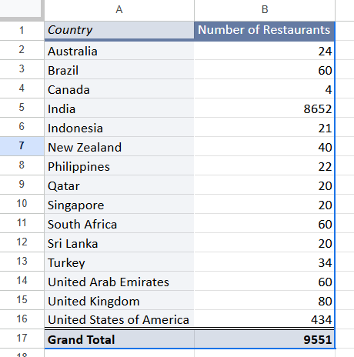

1. Also, the management wants to look at the number of restaurants opened each year, so provide them with something here.

First i used the formulae =LEFT(TRIM(U2),4)to extract the year then used vlookup in sheet SQ-8

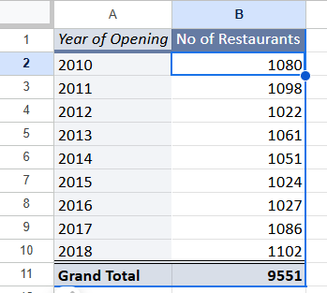

1. What is the total number of restaurants in India in the price range of 4?

By using the formulae =COUNTIFS('Raw Data'!D:D,"India",'Raw Data'!Q:Q,4) i got the total count of restaurants in india with price range of 4 is **388**

1. What is the average number of voters for the restaurants in each country according to the data?

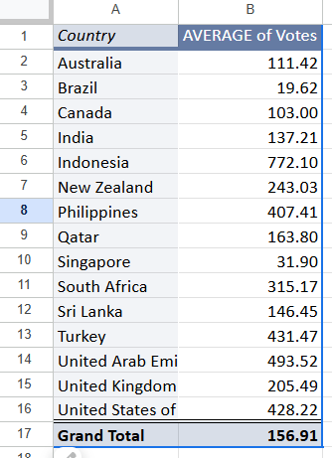

1. Calculate the average rating for all the restaurants that have price_range < 4 and provide online delivery. Use only the “IF” function, Logical Operators, and Aggregation functions to solve this problem. **[Note: Don’t use Conditional aggregation in this question.]**

I used the array formulae to get the average rating without using the aggregate functions

=ARRAYFORMULA(AVERAGE(IF(('Raw Data'!N2:N9552 = "Yes") * ('Raw Data'!Q2:Q9552 < 4), 'Raw Data'!T2:T9552)))

1. Using Conditional formatting highlight the rows of restaurants that are located in the countries or cities that you’ve suggested to the management for opening new restaurants.
2. Create a new customized price column that consists of the abbreviation/symbol of the currency along with the Average_cost_for_two value. [Use string operations to do this task]

I used left function right function ,find function and substitute function and & function to achieve this  
=LEFT(RIGHT(L2, LEN(L2) - FIND("(", L2)), LEN(RIGHT(L2, LEN(L2) - FIND("(", L2))) - 1)

&S2

1. How can you create an array formula in Excel or Google Sheets to count the number of restaurants listed that do not offer online delivery, are in the lowest price range, and have an average cost for two people less than or equal to 250 Indian Rupees?

I added country and currency in the sheet **OQ-11 then used vlookup to get the currency to one column in raw data which i used as helper column then multiplied this helper column with the price for 2 and next i used below formulae to get the requirement as mentioned in question**

**=COUNTIFS('Raw Data'!N:N,"No",'Raw Data'!Q:Q,1,'Raw Data'!Z:Z,"<=250")**

**And the result is 1694**

**Subjective Question:**

1. Suggest a few countries where the team can open newer restaurants with lesser competition. Which visualization/technique will you use here to justify the suggestions?

For suggesting the countries where we can open restaurant i first chosen the restaurants whose ratings are below 4 and also took an average of count of restaurants and also to also took the restaurants where the average of all restaurants is 65 so i filtered restaurants which are less than 65 and after applying above criteria i got canada singapore srilanka and brazil as suggested countries.

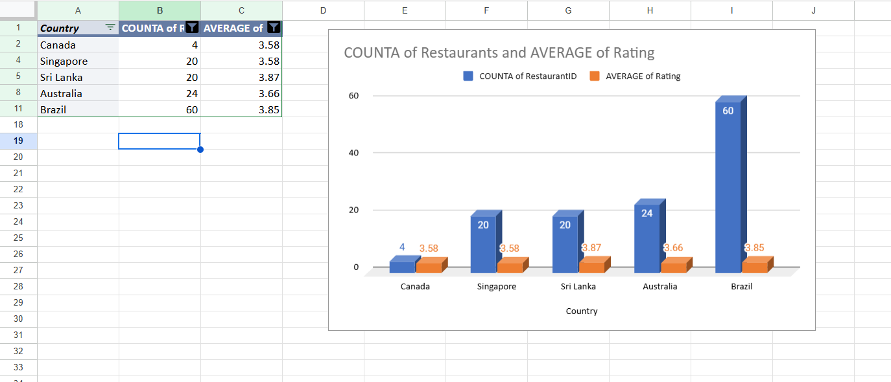

1. Come up with the names of States and cities in the suggested countries suitable for opening restaurants.

So from the countries i suggested i added same conditions as rating less than 4 restaurants less than 65 and also excluded the restaurants which are not in the selected country as in subjective question 1 and finally got the below cities to start the restaurants

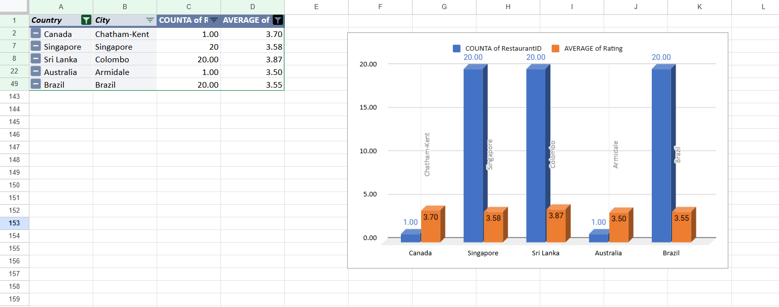

1. According to the countries you suggested, what is the current quality regarding ratings for restaurants that are open there?

The current quality ratings of restaurants that are open in the suggested states are as below

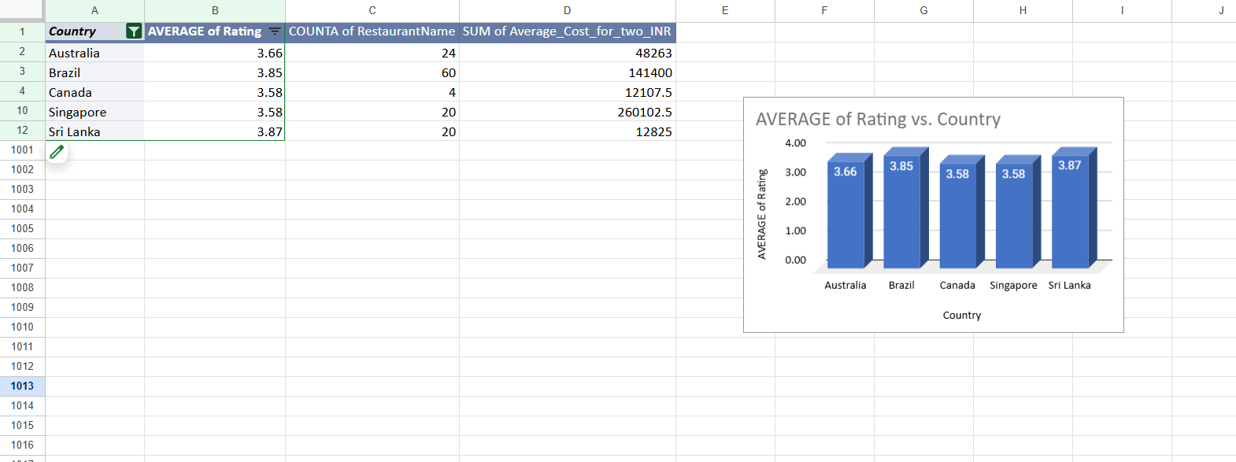

1. Also, what is the current expenditure on food in the suggested countries, so we can keep our financial expenditure in control?

The current expenditure on food in INR is as below

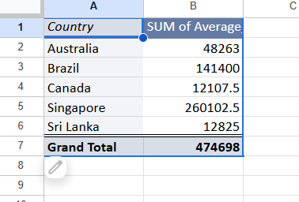

1. Come up with the names of restaurants from the recommended states that are our biggest competitors and also those that are rated in the lower brackets, i.e. 1-2 or 2-3.

So from my analysis from the recommend states below restaurants are competitors where the ratings are high in the given rating range.

| Consort Restaurant |
| --- |
| Chez Michou |
| Makansutra Gluttons Bay |

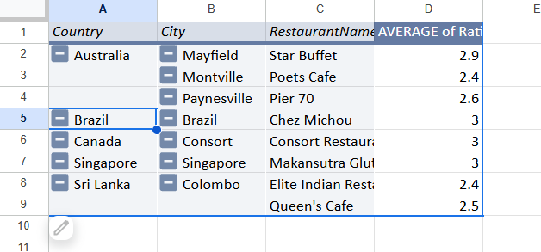

1. Which cuisines should we focus on in the newer restaurants to get better feedback? Does the choice of cuisines affect the restaurant ratings?

Focusing on the high rated dishes increases the rush in the restaurant because we are serving the most liked ones.

| Pizza, Bar Food |
| --- |
| Cafe |
| Breakfast, Modern Australian |
| Mediterranean, Seafood |
| Modern Australian, Australian |
| Australian |
| International |
| Italian |
| Mexican, Grill |
| Bakery, Sandwich, Brazilian |
| Beverages, Bar Food, Fast Food |
| Brazilian |
| Brazilian, Bar Food |
| Brazilian, Healthy Food, Juices, Pizza |
| Brazilian, Seafood |
| Burger |
| Desserts, Cafe |
| Japanese |
| Juices, Healthy Food |
| Lebanese |
| BBQ, Grill, Brazilian |
| Beverages, International |
| Brazilian |
| Brazilian, Bar Food, Beverages |
| Brazilian, Italian |
| Brazilian, North Eastern |
| French, Brazilian, Beverages |
| Gourmet Fast Food, Burger |
| Italian |
| Italian, Pizza |
| Lebanese, Arabian |
| Steak, BBQ |
| Italian, Mediterranean, Pizza |
| Bakery |
| Italian |
| American, Fast Food, Steak, Beverages |
| Continental, American |
| Continental, American, Seafood |
| Desserts, Bakery |
| Desserts, Ice Cream |
| Fast Food |
| Juices, Desserts |
| Middle Eastern, Arabian |
| Seafood |

1. According to our current data, should we go

for online delivery and table booking? Does that affect the customer’s ratings?

We should definitely go for the online delivery and table booking because the ratings are higher if there is table booking and online delivery

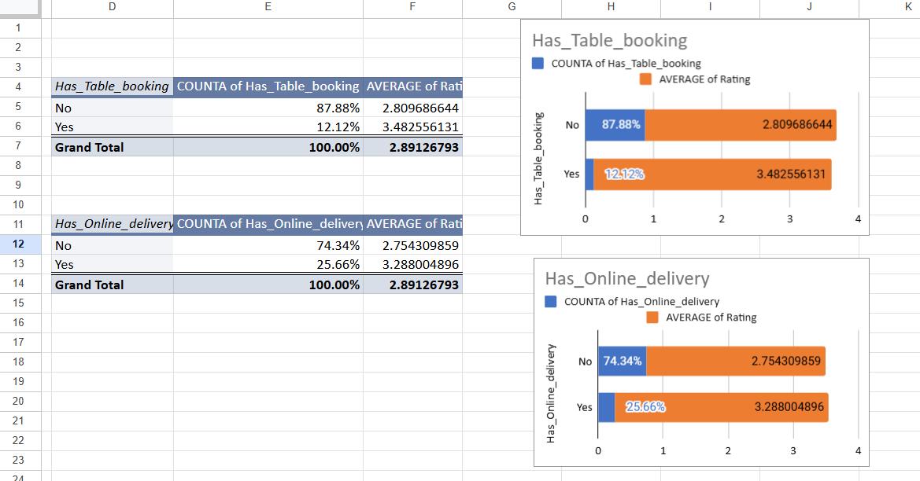

1. Should the team keep the rate of cuisines higher? Will that affect the feedback? According to our data are the rates of cuisines and ratings, correlated?

**Yes**, because the correlation is moderate and positive, meaning restaurants that offer more rate of cuisines tend to receive higher ratings. And when cousines increases feedback increases.

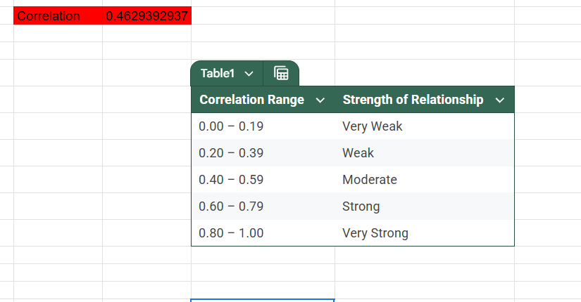

1. What is the distribution of the number of restaurants of different price ranges in all the countries?

So the total distribution of number of restaurants are as below

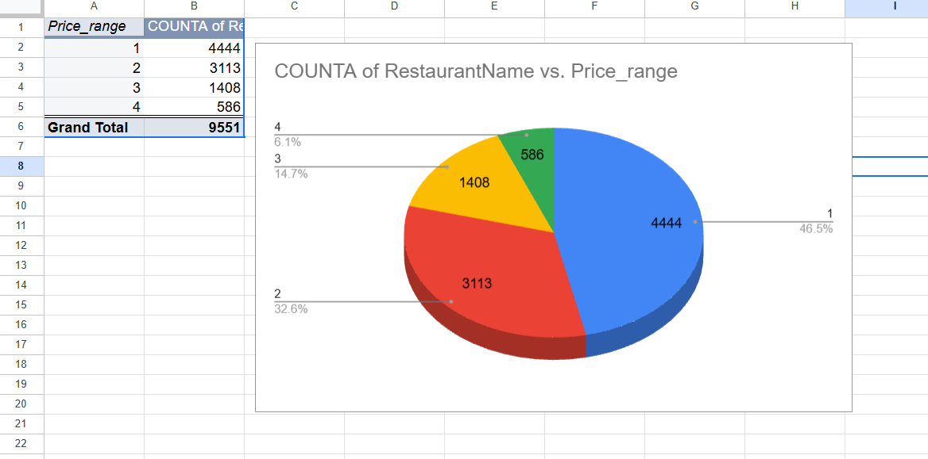

1. Explain your approach in brief for suggesting countries/cities in order to open new restaurants, if the objective and subjective questions would have not been given to assist you. **[you have to give bullet pointers in order to answer this question]**

* Clean & normalize data
* Identify restaurant saturation per country
* Analyze average rating per country/city
* Filter low competition and high opportunity areas
* Examine price sensitivity (currency + cost)
* Study impact of services (online delivery/table booking)
* Correlate cuisines with ratings
* Recommend cities based on demand gaps

**The dashboard must consist of Year-wise and country slicers.**

